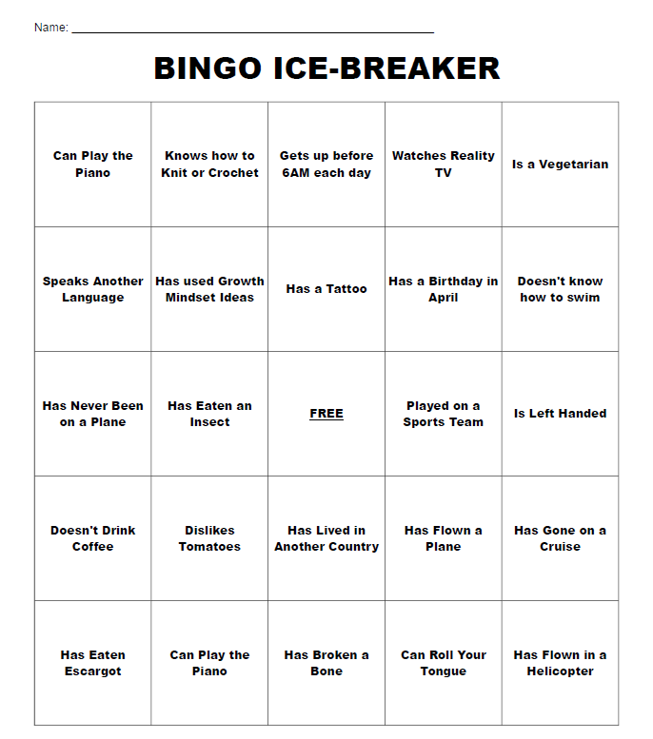
Ice Breaker – People Bingo

Syllabus Scavenger Hunt
Review the class syllabus with your team, and look for answers to the following questions:

- Class Policies:
  - What are the days and hours of our class?
  - What is my professor’s name (spelling!) and e-mail address?
  - What materials do you need for the class?
  - What is the calculator policy for this class?
  - What is the minimum point total to pass the class?
  - How many class days can you miss before you are dropped from the class?
- Homework:
  - How many homework assignments will be collected?
  - How will homework be graded?
  - When is homework due?
  - Can homework be turned in late??
- Quizzes and Exams:
  - How many quizzes will be given?
  - How many quizzes are dropped from your grade?
  - How many exams will be given?
  - What happens if you miss an exam?
  - How many exams are dropped from your grade?
- Participation Points:
  - How do you earn participation points?
  - How many participation points can you earn?
  - How do you lose participation points?
- Student Behavior:
  - Name two actions that can lead to disciplinary measures.
  - What happens if you miss class during the add/drop period (the first two weeks of the semester)?
What questions do you have that were not answered in the syllabus?
1.
2.
3.
List the names and contact information for THREE classmates – form a study group NOW and decide when you will have your first meeting!
- 2. 3.

Educational Autobiography

Tell me the story of your educational history—the journey you’ve been on, the good, the bad, how you have felt about yourself as a learner in your past schooling, whether you felt “intrinsic motivation.” Paint a picture. Make it detailed so that I can start to get to know you and learn about your experiences.

Some things I would like you to include:

- Describe one particularly good experience you had in your past education and tell us about why it was good.

- Describe one particularly bad experience you had in your previous education and tell us about why it was bad.

- Please include some discussion of your past experiences with math. If you enjoy math, why? If you don’t, why not? Do you feel confident in your math skills? Do you feel a desire for mastery? Do you feel a sense of purpose about developing math skills?

- Please close by bringing us up to the present and the future —what do you want to get out of this particular math class at Citrus College? Is there anything you’d like your professors to know so that we can support your learning? Is there anything you’re concerned about? Is there anything you feel excited about?

